WriteUp LKS Sekolah - Daerah Istimewa Yogyakarta

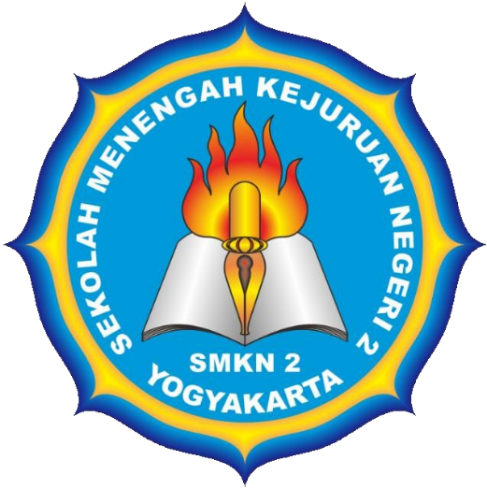
SMKN 2 Yogyakarta
Arsad Azami Nursamal
Mirza Razaq

Web exploitation 3
Cryptography 3
Reverse engineering 3
Forensic 3
Binary exploitation 3
Blockchain 3
Artificial intelligence 3
Miscellaneous 3
Osint 3
Liburan di jawa tengah 3
Template{} 3

Web exploitation

Cryptography

Reverse engineering

Forensic

Binary exploitation

Blockchain

Artificial intelligence

Miscellaneous

Osint

Liburan di jawa tengah
250
Isi:

Template{}

